**Name:-Patil Darshana Mohandas**

**Roll No:-128**

**Practical No:-1**

**Practical Name :-Set up a GitHub account and send an email message to friend telling to your friend about the account**

**1.Open** [**https://github.com/KBCIMR**](https://github.com/KBCIMR) **in a web browser and select thee sign up.**

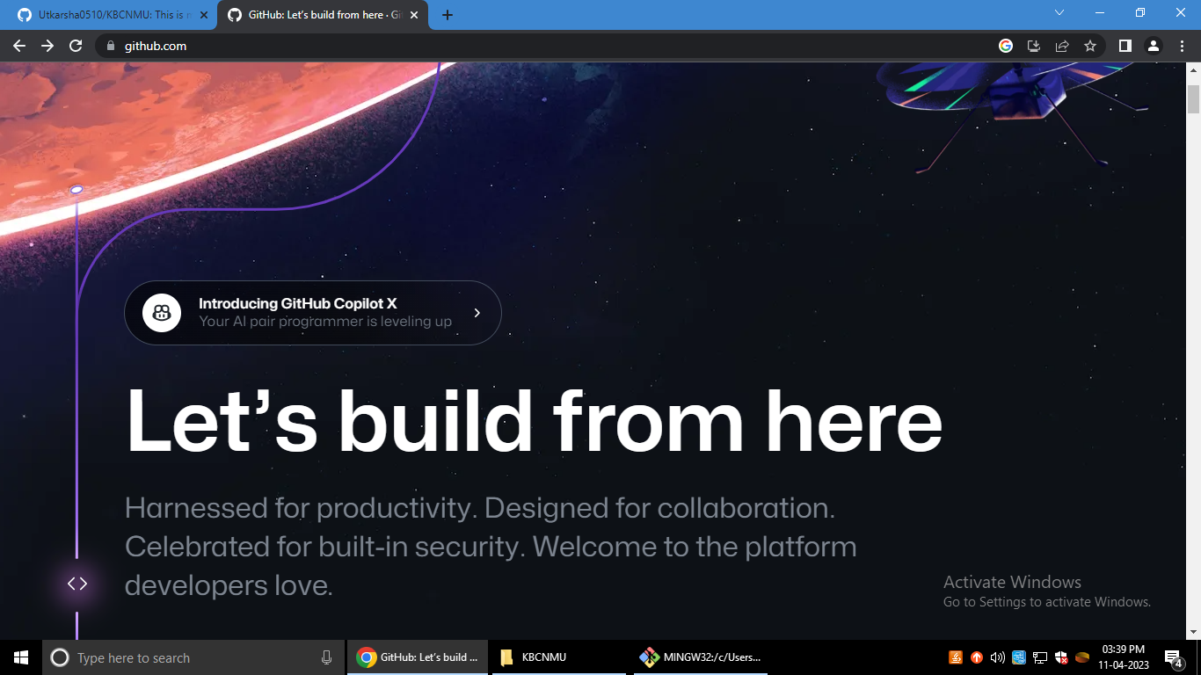

**2.Enter the Email Address**

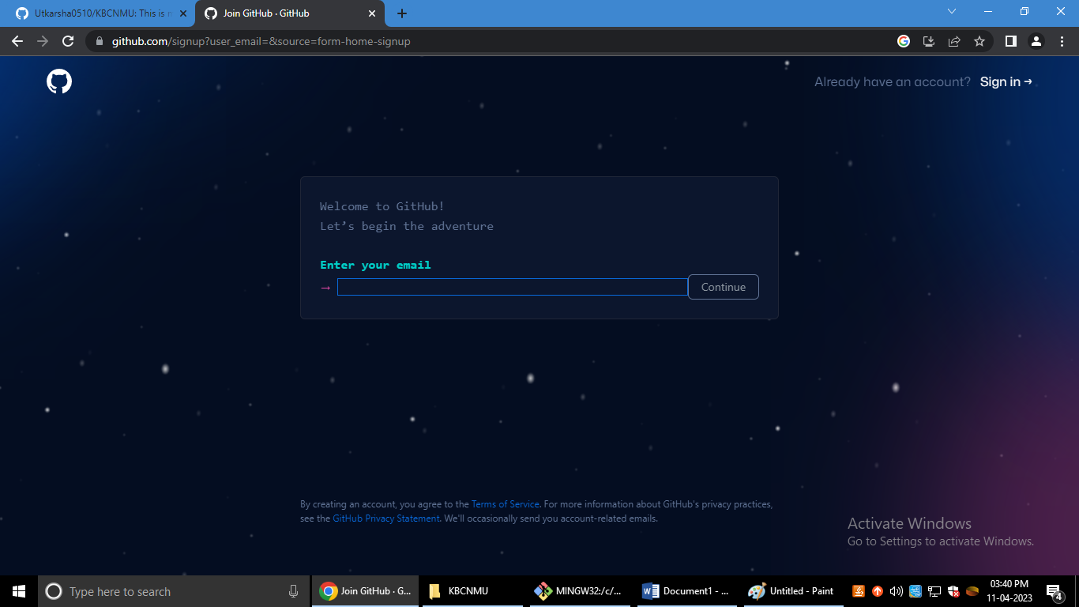

**3.Create a Password**

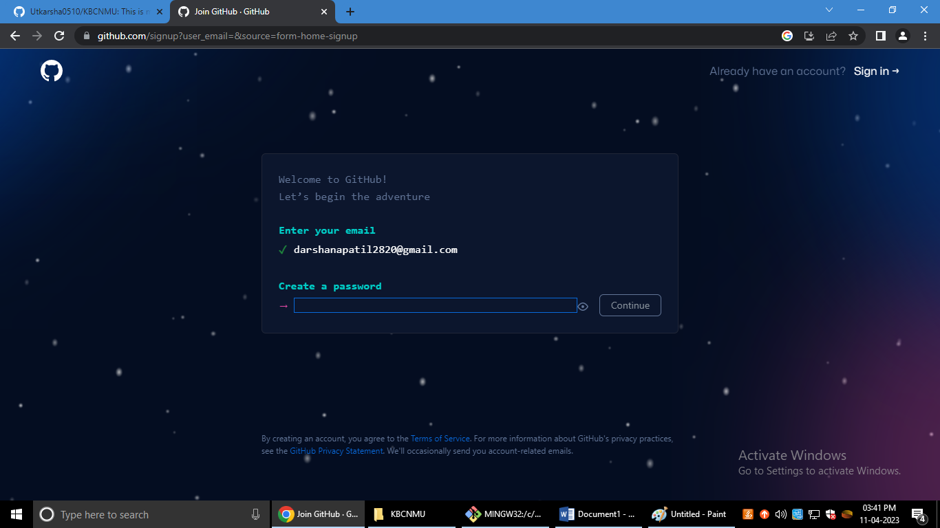

**4.Enter the Username**

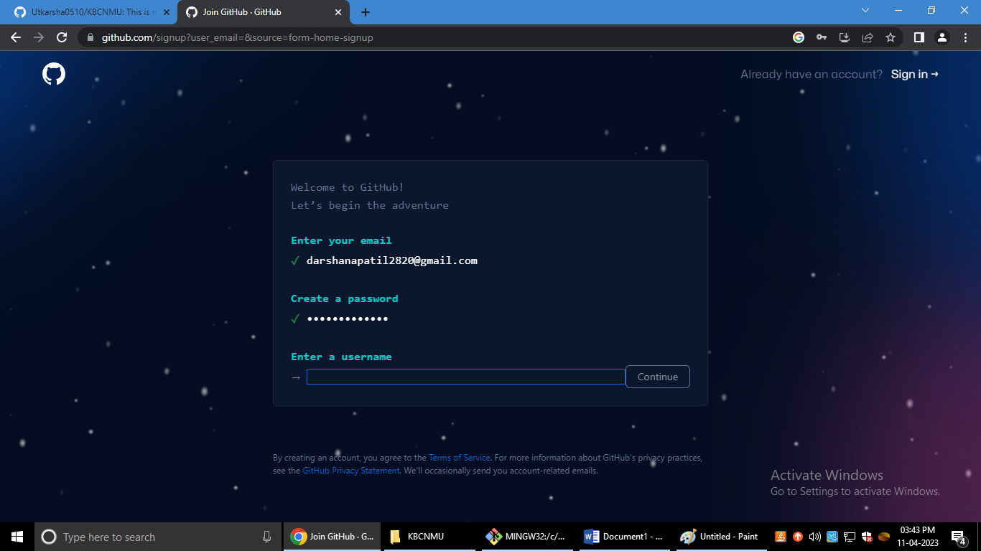

**5.Would you like to receive product updates and announcement via email?**

**Type “y” for yes or “n” for no**

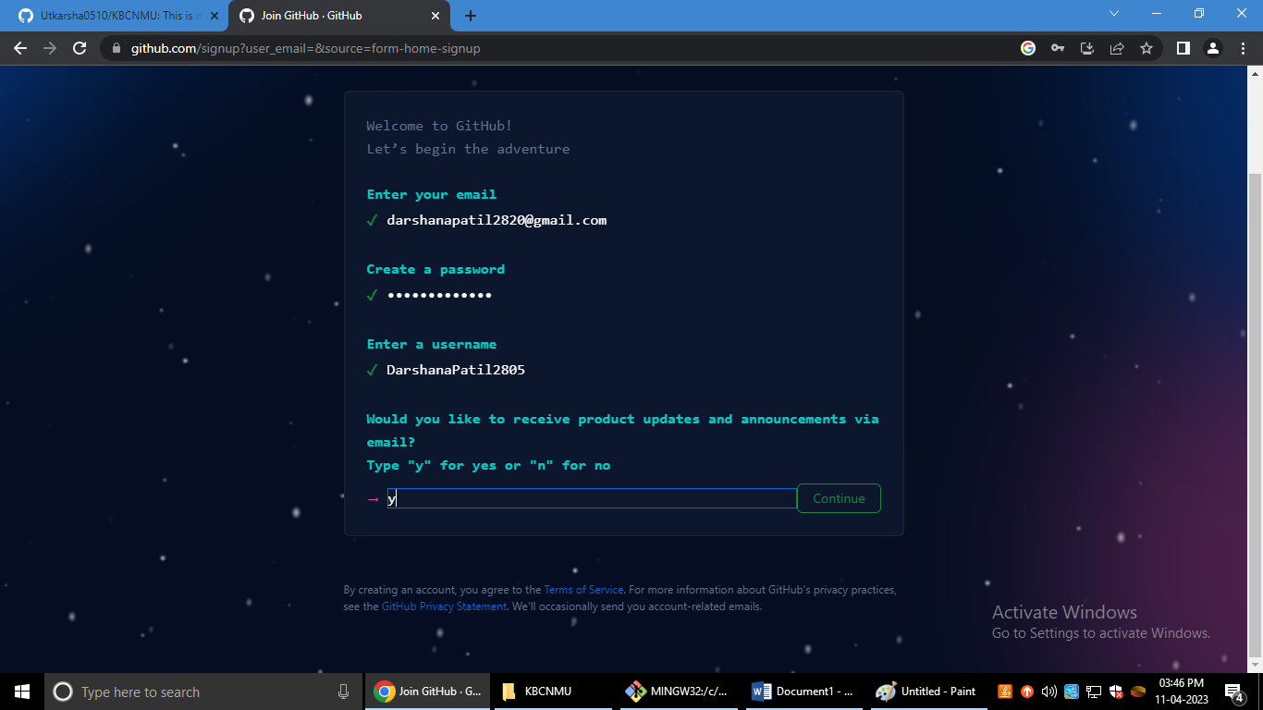

**6.Verify your account**

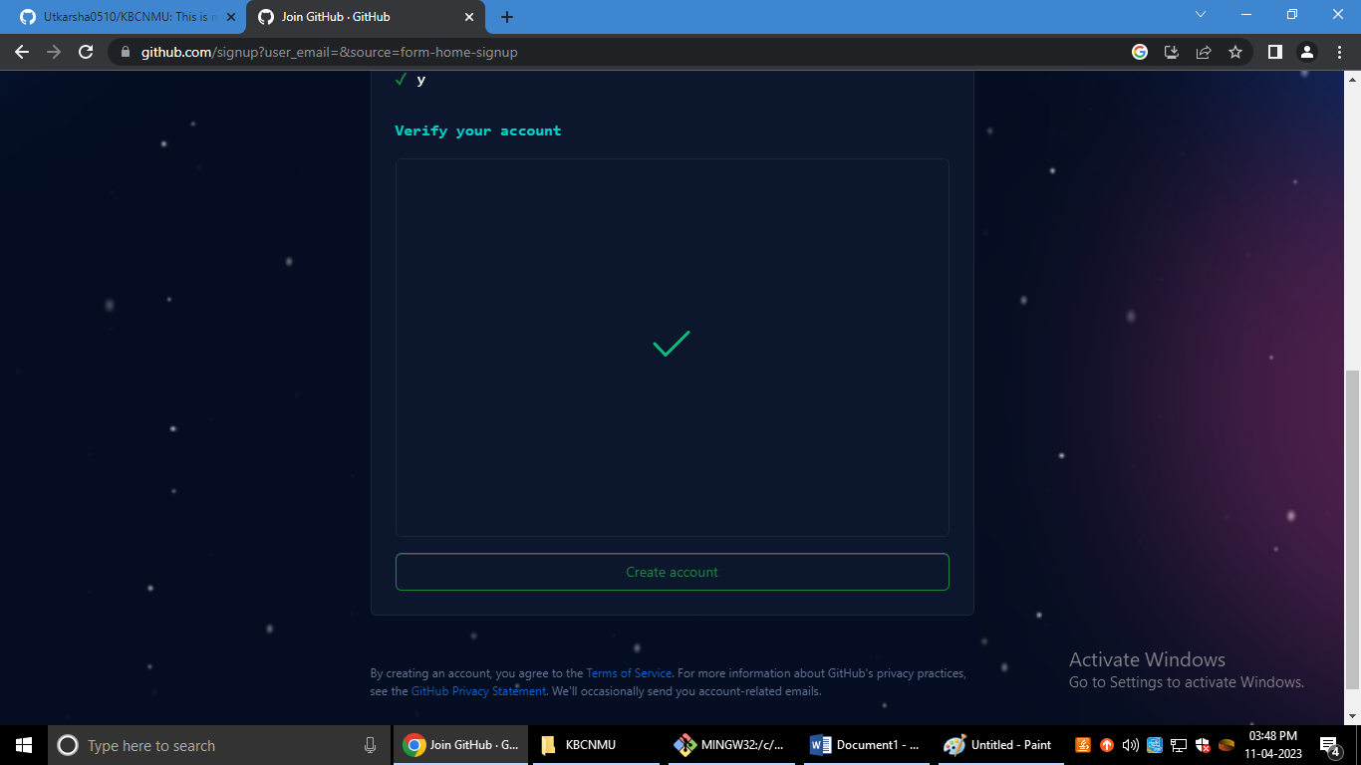

**7. Enter the Code**

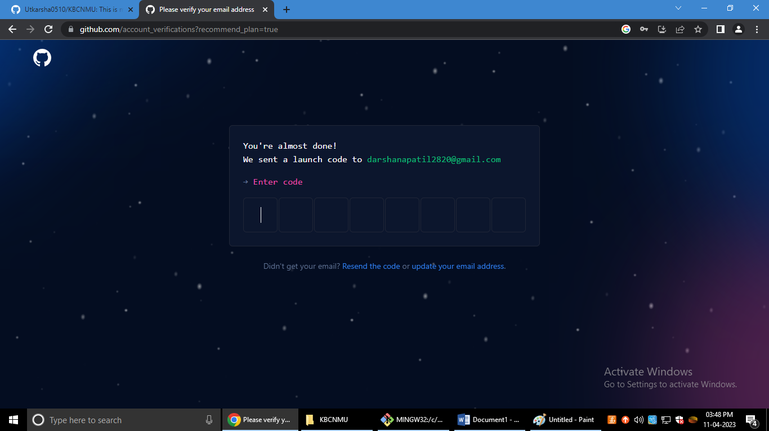

**8.**

